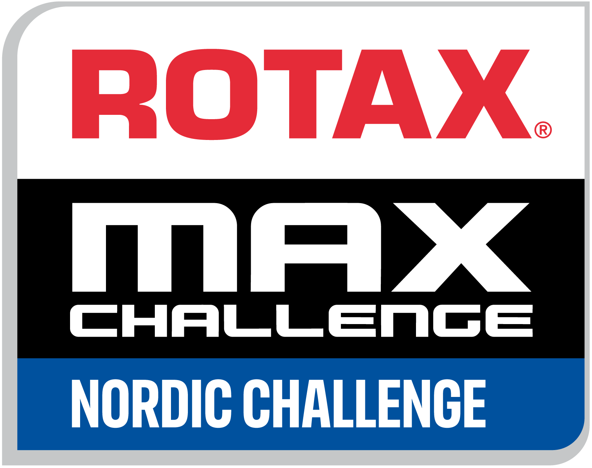

Event supplementary Regulations
Rotax Nordic Challenge 2022 | ROUND 2
Rotax Estonian Championship 2022 |ROUND 4
Aravete karting track

These are the supplementary regulations for round 2 of ROTAX NORDIC CHALLENGE 2022 and round 4 of ROTAX Estonian Championship that take place in Aravete Karting track, Kurisoo, Ambla parish, 73514, Estonia, from 22nd till 23rd of July, 2022
Approved in Estonian Autosport Union on 22nd of June. Registration number is 74/KA

REGULATIONS
The final text of these Supplementary Regulations shall be the English version, which will be used, should any dispute arise as to their interpretation. Headings in this document are for ease of reference only and do not form part of these Supplementary Regulations. The language written and spoken shall be English.

ARTICLE 1 – ORGANISATION
The Series and its Event’s shall be run in accordance with the FIA International Sporting Code “ISC” and its appendices, the CIK-FIA Technical Regulations, the FIA and CIK-FIA official Bulletins, the General Prescriptions applicable to CIK-FIA Karting Events, Article 3 International Karting Regulations and International Karting Licenses for Drivers & Code of Driving Conduct, Estonian Karting Race Regulations, Rotax Nordic Challenge 2022 Sporting and Technical Regulations, Rotax Max Engines Technical Specifications 2022 and the Supplementary Regulations of each Event of the Series.

1.1 Changes to the Supplementary Regulations will be announced by bulletins issued by the Organiser or the Stewards.

1.2 The competition is held as a national competition, at the discretion of the EASU. The participation of license holders from other ASNs is accepted.

1.3 FIA International Sporting Code is published at www.fia.com and https://uus.autosport.ee, CIK-FIA General Prescriptions is published at www.cikfia.com.
Estonian Karting Sporting and Technical Regulations, the Nordic Challenge Sporting Regulations, these Supplementary Regulations is published at https://uus.autosport.ee/kart.

ARTICLE 2 - INFORMATION SPECIFIC TO THE SERIES AND EVENTS

2.1 Rotax Nordic Challenge is organized by Rotax Authorized Distributor in the Baltic region:
Kart Baltic Group OÜ
Kadaka tee 183A Tallinn,
Estonia,
Tel: +372 5065609
e-mail: ags@ags.ee
web: www.rotax.ee

2.2 Organization and race Office:

Organizer:
MK Kardikeskus OÜ
Kraavi 7-29, Türi
Estonia
Tel: +372 504 20 27
Email:info@karting.ee
Race office:
Aravete karting track
Kurisoo, Ambla Parish, Estonia,
Tel: +372 504 20 27
Contact: Margus Leesma
Email: info@karting.ee
2.3 Dates (detailed timetable attached)
21st JULY | Paddock gates open, Free practice,
22nd JULY | Official free practice, Race registration, Race tire collection, Scrutineering
23rd JULY | Warm up, Qualification, Final 1, Final 2, Super Final and Podium

2.3.1 Team setup in paddock

TENTS
Each team is responsible for their own equipment to safety set up team tents.

USED TIRES
After / during the race the used tires will have to be put in a designated area for this purpose.

2.4 Entries
Entry must be made on the web http://www.rotax.ee/ / https://www.rotax-ems.com/EST/

2.5 Dates Open & Closing for Entries.
Rotax Nordic Challenge Round 2 entry Open Date: 18th April 2022 - Closing Date: 16th July 2022.

2.6 Entrants’ Applications
Applicants must hold a valid International or National Entrants’ Licenses and the necessary authorizations (visa) issued by their ASNs Affiliated to the FIA.

2.7 Amounts of fees
Admission fee for all classes for the event is 180,00 EUR (Friday – Saturday). Late Entry is 210 € (If entry is accepted).
Free practice day – 40,00 EUR .
For drivers in the Micromax and Minimax classes, an additional exhaust system rental fee of 20 euros is added to the registration fee.
Transfer pre-payment based invoice can be made till 18.07.2022 by requesting an invoice to email info@karting.ee. Afterwards payment will only be possible in cash, on site of the event.

  - Entry Restriction:
Drivers are allowed to enter one class /category only

2.9 Categories:
According to Rotax Nordic Challenge Sporting regulations in all categories max entries 34. If number of entries exceeds 34 entrants- the selection will be done according to registration order.

2.9.1 Rotax Micromax

2.9.2 Rotax Minimax

2.9.3 Rotax Junior Max

2.9.4 Rotax Senior Max

2.9.5 Rotax DD2

2.9.6. Rotax DD2 Masters

  - Licenses & Visa
According to Nordic Challenge Sporting Regulations; drivers have to have license that is issued by an ASN which is member of CIK/FIA. For all RNC classes international license grade G, F, E or National Kart license is required.

  - Officials for the competition:
Steward: J.Karzjuks
Race Director / Steward: D.Viksne
Steward: TBD
Head of Scrutineers: D. Golovacovs
Competition Head Secretary: Eda Leotoots
Distance chief: A.Gravelsins
Start-finish Referee: K.Balulis
Participant referee: T.Lejins
Annoucer: T.Klaar
Timekeeper: Asper Leppik

2.12 Prizes and awards
In all 6 categories TOP3 Rotax Nordic Challenge 2nd round drivers will be awarded individually from race organizer. Race suit is required.

ARTICLE: 3 ORGANISER’S SUPPLEMENTARY PROVISIONS

3.1 Dry tires
Dry tires must be purchased from the organizer of the race.
Transfer pre-payment based invoice can be made till 18.07.2022 by making an order on this form https://forms.rotax-scc.com/view.php?id=145292. Afterwards payment will only be possible in cash, on site of the event.

Each driver in all classes can use during the Event 1 set of tires.

TIRE PRICES
- 170 EUR | set MOJO C2
- 190 EUR | set MOJO D2
- 200 EUR | set MOJO D5

3.2 Wet tires
Wet tires can be purchased on drivers own choice
- 210 EUR | MOJO W5 (4,5/6,0)
- 180 EUR | MOJO CW (4,5/4,5)
Competitors must use their own wet tires during the competition, which must be registered together with their assigned set of dry tires.

3.3 Marked direction
Marked direction must be adhered to for all tires at all time, karts / Drivers with incorrectly mounted tires will be penalized DQ

3.4 Tires used for free practice
Additional tires used for free practice (same production date as race tires) can be ordered from organizer of the event- via race office.
For order fill in this form https://forms.rotax-scc.com/view.php?id=145292

3.5 Warm up
Warm up the tires are free of choice.

3.6 Petrol - Rotax Micro, Mini, Junior, Senior, DD2, DD2 Master

a) It is allowed to use only petrol that is purchased form Cirkle-K “Märjandi”, Ambla Parish, Järvamaa, 73513.

b) The Petrol must be unleaded commercial pump fuel, the octane is up to drivers’ choice TBA (95 or 98)

c) The oil mixture minimum rate 50:1 (2%)

d) It is forbidden to add any liquid and/or power-boosting chemicals in the petrol.

e) At any time the volume of the fuel in the tank must be over or equal to 0,5 liters

f) The Scrutineer, following a decision of the Stewards, has the right to change/replace any driver’s petrol at his discretion, at any time.

Case 1 - Should this be the case the Drivers will be asked to enter servicing park without petrol in his/her petrol tank, where the fuel will be added, at the cost of 3,5€ liter for the Driver/ Entrant. The added petrol will be the petrol as stated in the supplementary regulations of the event.

Case 2 - Petrol will be changed without warning, at the cost of 3€ liter for the Entrant / Driver. Changed/Replaced petrol will be the petrol as stated in the supplementary regulations of the event.

ARTICLE: 4 - THE EVENT

The “Rotax Nordic Challenge Round 2 2022” will consist of:
- A Non-qualifying official practice
- Qualifying;
- 1st Final;
- 2nd Final.
- Superfinal;

4.1. Numbers on karts
The numbers on the karts should be black (without shadow and/or color stripes) on a clear Yellow Back-Ground, and they shall be at least
14 cm high and have a 2 cm thick stroke and represented with an Arial type or similar font. The competition number shall be bordered by a yellow background of 1 cm minimum. They must be fitted before free practice and must be clearly visible during the whole race event (damaged numbers must be replaced regularly) on both front and rear and on both sides towards the rear of the bodywork. The number plates fitted at the back of the kart shall be plane and have rounded corners (diameter of rounded corners 15 to 25 mm) with 22 cm sides. The plates shall be flexible and made of opaque plastic, and they shall always be visible (fixation without a possible displacement).
Racing numbers for each category are:
Micro MAX 1to 99
Mini MAX 101 to 199
Junior MAX 201 to 299
Senior MAX 301 to 399
DD2 MAX 401 to 499
DD2 MAX Master 501 to 599
The name and the country flag of the driver will always be presented on each side of the lateral bodywork and be clearly legible during all events.
The flag of the driver’s nationality shall be that of the nationality of his race licence

4.2. Official practice
The Official Practice on Friday before race event.
All Drivers before taking part in official practice, must have numbers and names on the kart. Every group will have their practice according to the timetable. The official practice is only for Entered Drivers.

4.3. Protests and appeals
4.3.1 Protests and appeals must be submitted according to Art 13 and Art 15 of the FIA Sporting Code.
4.3.2 Right to protest
4.3.3 The right to protest lies only with a competitor.
4.3.4 Several competitors cannot lodge a joint protest.
4.3.5 A competitor wishing to protest against more than one fellow competitor must lodge as many protests as there are Competitors involved in the action concerned.
4.4 Protest fee
Protest must be submitted in writing to the Clerk of the Course or his deputy no later than 10 minutes after the publication of the provisional results of the qualification and no later than 30 minutes after the publication of the provisional results of the heat or the final. Protest must be accompanied by a deposit in the amount of 300 euros in cash.
In the absence of the Clerk of the Course or his deputy, protests will be submitted to the secretary of the competition.
4.5 Appeals
Competitors and drivers have the right to appeal against the decision made by the Stewards in accordance with the FIA Sporting Code Art 15.4. The appeal deposit is 3000 € (set by the EASU).

